Appendix I
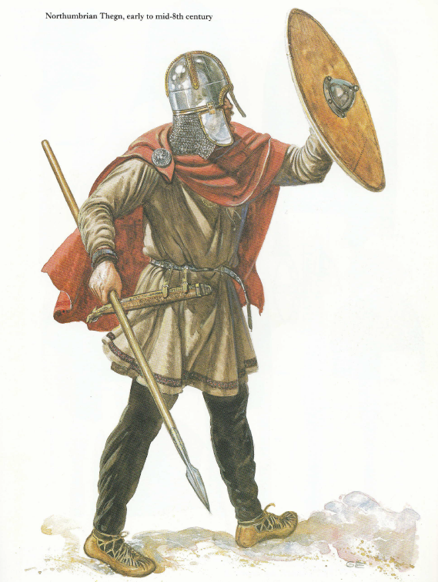

Mid-8th century Anglo-Saxon thegn
Appendix II
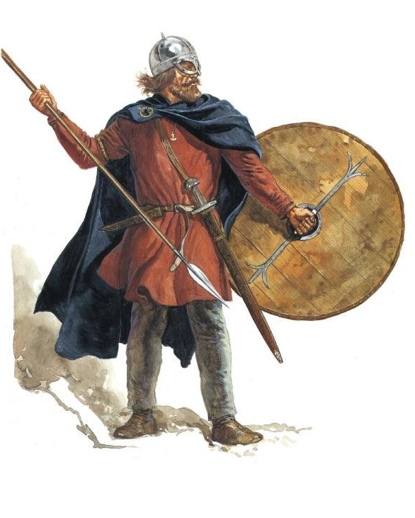
Viking hersir, 8th - 9th Centuries

Mark Harrison, Anglo-Saxon Thegn AD 449-1066, (Oxford: Osprey Publishing, 1993), F.
Mark Harrison, Viking Hersir 793-1066 AD, (Oxford: Osprey Publishing, 1993), F.

